DPS Biblical Archeology Study – Teacher’s Guide
5. The Patriarchs
Overview
a. Inscriptions and Writings: The Rosetta Stone
b. Abraham and his family
Discussion Questions
a. Inscriptions and Writings: The Rosetta Stone
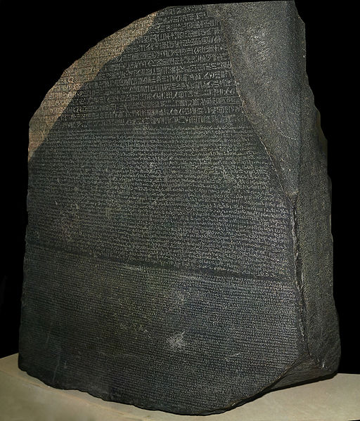
is an ancient Egyptian granite stele inscribed with a decree issued at Memphis in 196 BCE on behalf of King Ptolemy V. The decree appears in three scripts: the upper text is Ancient Egyptian hieroglyphs, the middle portion Demotic script, and the lowest Ancient Greek. Because it presents essentially the same text in all three scripts (with some minor differences between them), it provided the key to the modern understanding of Egyptian hieroglyphs.
Originally displayed within a temple, the stele was probably moved during the early Christian or medieval period and eventually used as building material in the construction of Fort Julien near the town of Rashid (Rosetta) in the Nile Delta. It was rediscovered there in 1799 by a soldier, Pierre-Francois Bouchard, of the French expedition to Egypt.
Inscriptions from a culture furnish the most objective information. Further, they preserve for us what cannot be seen in artifacts, such as history of the nation.
Abraham and his Family
Abram, or as he is later called, Abraham, is seen in history as the father of both the Jews and the Arab nations. Judaism, Christianity and Islam hold him up as a spiritual leader.
The Family of Abram.
And Haran died in the presence of his father Terah in the land of his birth, in Ur of the Chaldeans.
And Abram and Nahor took wives for themselves. The name of Abram’s wife was Sarai; and the name of Nahor’s wife was Milcah, the daughter of Haran, the father of Milah and Iscah. (Genesis 11:28-29)
The laws of incest in that day were not nearly so strict as they are today. It was considered commonplace for an uncle to marry his niece. The family tree of Abram looks like this.
In the case of Laban, the nephew of Abram and the uncle of Jacob, the most that we can say is that he considered Yahweh to be one of many tribal gods. Only in Abram do we find a man who worshiped Yahweh exclusively.
THE LAND OF CANAAN
And Abram took Sarai his wife and Lot his nephew, and all their possessions which they had accumulated, and the persons which they had acquired in Haran, and they set out for the land of Canaan; thus they came to the land of Canaan. (Genesis 12:5).
If Haran is the hub of the wheel, then Canaan is one of the major spokes of that wheel. The land of Canaan acts as a narrow land-bridge between Mesopotamia and the continent of Africa.
This is a relatively small area of land, no larger in area than Lake Erie or the state of Maryland. The name Palestine takes its name from the ancient name Peleset, meaning “land of the Philistines.”
ABRAHAM IN CANAAN
As Abraham first entered the land of Canaan, he traveled down the Central Mountain Ridge to the site of the ancient town of Shechem.
And Abram passed through the land as far as the site of Shechem, to the oak of Moreh. Now the Canaanite was then in the land.” (Genesis 12:6).
The town of Shechem would later be built in the pass that runs between Mount Ebal and Mount Gerizim. It would be on this site that Jesus would later hold an afternoon discussion with a woman by the well.
When the Scriptures says that the Canaanite was then in the land, it is a reminder that the land of Canaan was not some uninhabited wilderness. It was a land of cities and towns, of merchants and farmers and shepherds.
Abraham came into this land as a nomadic shepherd-merchant. He did not take up residence in any of the Canaanite cities, but remained a pilgrim and a nomad. His sojourn seems to have been seasonal at times, especially in times of famine.
ABRAHAM IN EGYPT
Now there was a famine in the land; so Abram went down to Egypt to sojourn there, for the famine was severe in the land. (Genesis 12:10).
Upon finding a famine in the land of Canaan, Abraham moved his family south to Egypt. The pyramids and the Great Sphinx were already hundreds of years old as Abraham entered Egypt.
This was the First Intermediate Period of Egypt’s history. It was a time of disunity as Egypt was broken up into several small feudal kingdoms, each attempting to gain power over its neighbor. During this period, it was not uncommon for foreigners to be permitted entrance into the country.
While Abraham is in Egypt, he falls into danger. Fearful of his life, he plots with his wife, Sarai, to pretend that she is his sister.
The reason for this deception is understood when we examine an Egyptian papyrus which records a pharaoh murdering the husband of a beautiful woman so that he could marry her.
SODOM & GOMORRAH
Upon returning to Canaan, Abraham has a falling out with his nephew, Lot. They go their separate ways and Lot moves down to the southern part of the Jordan Valley.
And Lot lifted up his eyes and saw all the valley of the Jordan, that it was well watered everywhere – this was before the Lord destroyed Sodom and Gomorrah – like the garden of the Lord, like the land of Egypt as you go to Zoar. (Genesis 13:10}.
The implication of this and other passages of the Bible is that the area of the Dead Sea was not the desolate wasteland that it is today. In that day, it was a fertile land.
Genesis 14 records the military campaign of an alliance of kings from the east.
o Amraphel, king of Shinar. Shinar was the general term for Mesopotamia. This may have been an Akkadian king.
o Arioch, king of Ellasar: Ellasar was another name of Larsa, a Sumerian city to the east of Ur.
o Chedorlaomer, king of Elam: The Elamites were located to the east of Sumer and were one of the most powerful countries in the world at this time.
o Tidal, king of Goiim: “Goyim” is the Hebrew word for “nations.” Tidal, on the other hand, is a Hittite name and might reflect an early Hittite alliance.
A coalition of these kings from the east invaded Canaan, conquering the cities of the Jordan Valley, and taking Abraham’s nephew, Lot, in the process.
Abraham gathered his own alliance of Canaanite chieftains and set out in pursuit, catching the invaders in a pincer movement in what is the first night attack recorded in history. Lot was rescued along with the spoils of the kings of the Jordan Valley. However, this served as only a temporary respite for the cities of the plain.
Sodom was the major city of the Jordan Valley in the days of Abraham. It was a beautiful, well-watered area. It had been for this reason that Lot had chosen to live there.
The Dead Sea today in the lowest spot on the face of the earth. The north part of the Sea is 1300 feet deep. Today the southern part has dried up completely. Scholars generally place the location of Sodom and Gomorrah in what is today this shallow, southern part of the Dead Sea.
Some distance from the shore and clearly visible under the surface of the water, are stretched the outlines of forests which the extraordinarily high salt content of the Dead Sea has kept in preservation. (Werner Keller, The Bible as History, pg 56).
The Bible records that Lord destroyed both these cities and everything else in the Valley.
Then the Lord rained on Sodom and Gomorrah brimstone and fire from the Lord out of heaven, 25 and He overthrew those cities, and all the valley, and all the inhabitants of the cities and what grew on the ground. (Genesis 19:24-25).
Confirmation from Archaeology.
A Phoenician inscription had this to say about the destruction of the “Vale of Sidimus.”
The Vale of Sidimus sank and became a lake, always evaporating and containing no fish, a symbol of vengeance and of death for the transgressor. (Attributed to Sanchuniathon, prior to the Trojan War).
This indicates that there was a time when the Dead Sea was not there and when the Jordan Valley was unbroken.
Confirmation from Geology.
Genesis 14:10 says that the valley was full of “tar pits.” Petroleum and asphalt deposits still exist around the Dead Sea today. It is a burnt-out region where nothing grows.
We have already mentioned that this area holds a massive fault zone. Throughout its history, it has been the scene of many severe earthquakes. It is possible that an earthquake combined with the explosive petroleum and asphalt deposits to cause a great explosion of “brimstone and fire.”
OTHER ARCHAEOLOGICAL NOTES FROM ABRAHAM’S DAY
1. Lot’s Door.
In Genesis 19:6, 9-10 we find several mentions of the door to Lot’s house in Sodom. It is described in terms of having been shut to keep out the men of Sodom.
Houses within cities did not always have doors in antiquity. A door would interfere with any cool breeze, making the heat of the land intolerable. Archaeologists have noted that there are different styles of doors for differing eras
Middle Bronze (2200-1600 B.C.) | Strong, sturdy wooden doors | No strong, centralized government
Early Iron II (800-600 B.C.) | Doorways consisted of archways and curtains | Kings of Judah and Israel provided centralized government
The smaller the police force, the greater the need for a stout wooden door.
2. Abraham’s Purchase of a Tomb.
In Genesis 23:16 we read that Abraham paid 400 shekels of silver. While today a shekel is a form of currency, in that day it was a weight designation. We think in terms of pounds or kilograms, they weighed in terms of shekels. It was not until around 700 B.C. that money began to be coined.

Discussion Questions:
In your view, were Abraham and Sarah historical persons? Would it affect your faith if they were part of a “patriarchal legend?” Do you find the archeological. geological and historical confirmations convincing? Do you believe God used the natural processes described above to allow Sodom and Gomorrah to be destroyed?

