Handout #3. Theories of the Flood
a. Inscriptions and Writings: Israel Stele
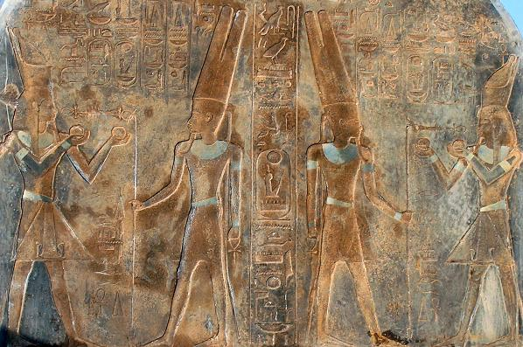
Also known as the Israel Stele or Victory Stele of Merneptah, it is the reverse of a large granite stele originally erected by the Ancient Egyptian king Amenhotep III, but later inscribed by Merneptah who ruled Egypt from 1213 to 1203 BC. The black granite stele primarily commemorates a victory in a campaign against the Libu and Meshwesh Libyans and their Sea People allies, but its final two lines refer to a prior military campaign in Canaan in which Merneptah states that he defeated Ashkelon, Gezer, Yanoam and Israel among others.
b. Scripture Reading: Genesis 7:1-20
c. Theories of the Flood
UNIVERSAL FLOOD | LOCAL FLOOD
The purpose of the ark was punishment of world-wide sin. In a local flood some could have escaped. | The word aretz is often used to describe a local area.
The authors of Genesis use language of totality. | The account is given from the viewpoint of the narrator is from his perspective; from that viewpoint the destruction is total.
The the ark indicates that this was no local flood. A vessel of this size would not have been needed to escape a local flood. | The ark, even though very big, could have never contained all then living species of animals.
d. Another Mesopotamian flood account from the Gilgamesh Epic
A number of earlier Sumerian stories about Gilgamesh, the quasi-historical hero of the epic, were used as sources, but the Akkadian work was composed about 2000 BC. It exists in several different recensions, none of them complete.
In the story, Gilgamesh and his friend Enkidu seek immortality through fame, but when Enkidu dies, Gilgamesh finds that fame to be hollow. Unable to accept the finality of death, he goes to Utnapishtim, the Babylonian counterpart of the biblical Noah, to learn the secret of his immortality.
This interview takes place on the 5th of seven tablets. Utnapishtim tells the story of how he was spared the destruction of the great flood through the building of a giant square barge.
o The boat consisted of seven decks and was overlaid with pitch.
o It took only seven days to build it.
o Utnapishtim saved his family and relatives along with animals and craftsmen.
o The flood began when “the gods of the abyss rose up; Nergal pulled out the dams of the nether waters, Ninutra the war-lord threw down the dykes, and the seven judges of hell, the Annunaki, raised their torches, lighting the land with their livid flame.”
o The storm lasted for 6 days and nights after which “the surface of the sea stretched as flat as a roof-top.”
o The boat landed atop the mountain of Nisir. After seven days on the mountain, Utnapishtim released a dove, then a swallow, and finally a raven before leaving the boat and making a sacrifice to the gods.
Utnapishtim goes on to explain that he received eternal life due to the unique circumstances of the flood, but he consoles the dejected Gilgamesh with news about a plant of life. A snake swallows the plant before Gilgamesh can use it, however, and he finally returns home, reluctantly accepting death without future resurrection as inevitable.
e. The quest for Noah’s Arc
Various claims of the discovery of fossilized pieces of the ark remain unsubstantiated.
Discussion Questions:
What are we to make of the fact that a document predating the book of Genesis also contains a story of the flood with many of the same aspects of the Biblical account? Does this mean that the biblical account has been copied? Or does it attest to the strong possibility of the Flood as an actual event? What theory of the flood do you find plausible? A universal flood or an extended local flood? Would a positive identification of fossilized pieces of the ark make a difference to your faith?

